Name: ___________________________________

Compare and Contrast
Directions: Fill in the Venn diagram with details about Cinderella and Yeh-Shen
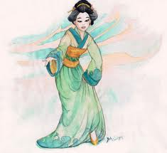
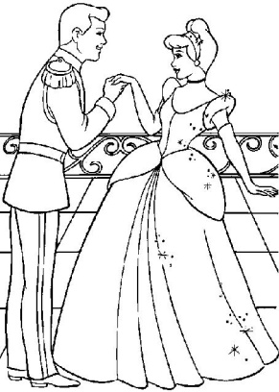
Cinderella Yeh-Shen

